MINISTRY OF EDUCATION AND SCIENCE OF THE REPUBLIC OF KAZAKHSTAN

INTERNATIONAL INFORMATION TECHNOLOGY UNIVERSITY

FACULTY OF INFORMATION TECHNOLOGIES

Department of Computer engineering and information security

COURSE PROJECT

Major 5B070400 – Computer systems and software engineering

Discipline Web technologies

Topic: _______________ Car rental system_______________________

|  |  |  |
| --- | --- | --- |
| STUDENT(S): | ITSE-1907 – Shotan Syrym______________  (group and student name) | _____________  (signature) |
| SUPERVISOR: | Assistant-professor  Alpysbay N.Y  (position, name) | _____________  (signature) |

Almaty 2021

# **Content**

Introduction

Main part……………………………………………………………………3

1 Theoretical part……………………………………………………………3

2 Design……………………………………………………………………..4

3 Implementation (creation of website)……………………………………..5

Conclusion

References

**Introduction**

The car rental project is a website where you can search for a car for rent in Almaty.

Car rental system is the most profitable way to travel without a personal car. This service will help you save money on city trips. You do not need to look for a taxi or order a taxi to transport things or go somewhere. Thus, car rental is unpretentious in any city.

I made a website where a car will be rented. Where you can see the prices, find out the characteristics, prices for cars.

Here you can choose the necessary car model for all occasions. If you value an increased level of comfort, or prefer reasonable savings - we will be happy to offer you exactly what you need. Among other things, our company offers car rental in Almaty without a driver, which is an extremely convenient solution for those who like to drive a car for their own pleasure. Our goal is your comfort and safety in any situation!

**Main part**

*Theoretical part:*

The definition of HTML is **HyperText Markup Language**.

* *HyperText* is the method by which you move around on the web — by clicking on special text called **hyperlinks** which bring you to the next page. The fact that it is *hyper* just means it is not linear — i.e. you can go to any place on the Internet whenever you want by clicking on links — there is no set order to do things in.
* *Markup* is what **HTML tags** do to the text inside them. They mark it as a certain type of text (*italicised* text, for example).
* HTML is a *Language*, as it has code-words and syntax like any other language.

What is **CSS**?

* CSS stands for Cascading Style Sheets
* CSS describes how HTML elements are to be displayed on screen, paper, or in other media
* CSS saves a lot of work. It can control the layout of multiple web pages all at once
* External stylesheets are stored in CSS files

**Bootstrap** is a powerful toolkit - a collection of HTML, CSS, and JavaScript tools for creating and building web pages and web applications. It is a free and open source project, hosted on GitHub, and originally created by (and for) Twitter.

**JavaScript** is a scripting or programming language that allows you to implement complex features on web pages — every time a web page does more than just sit there and display static information for you to look at — displaying timely content updates, interactive maps, animated 2D/3D graphics, scrolling video jukeboxes, etc. — you can bet that JavaScript is probably involved. It is the third layer of the layer cake of standard web technologies, two of which (HTML and CSS)

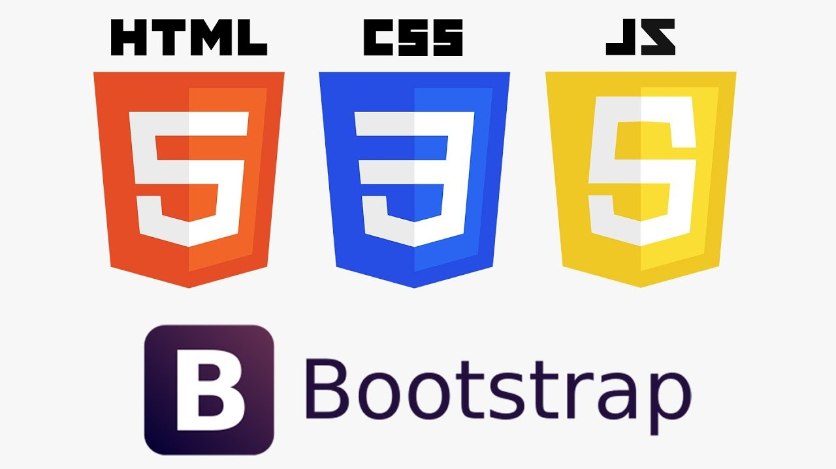

*Design:*

Website design is the design of content, the totality of all graphic elements on a web page. Previously, web design was understood exclusively as visual design, but now user convenience has come to the fore, so analytics and competent structuring of information on the site have been added to the tasks of a web designer.

The main task of the design is to introduce the user to the page. It facilitates the user's interaction with the web page, which means it has a positive effect on conversion and behavioral factors. Thoughtful design creates the right impression about the company.

We made the initial design of the site using Figma. Figma is a cross-platform online service for interface designers and web developers. The development of interfaces takes place in an online application.

Figma has two key functions: access to the layout directly from the browser window and the ability to collaborate on documents.

Before Figma, it was difficult for several designers to work on the same project and transfer layouts to developers. Photoshop refused to open the layout correctly until you installed the correct fonts. Or a colleague made changes to his copy of the project and forgot to tell you about it.

The Figma team took into account such problems and created a product that allows several designers to work on a project at the same time, supports

version control and provides many other functions. They make life easier for both the designer and the developer.

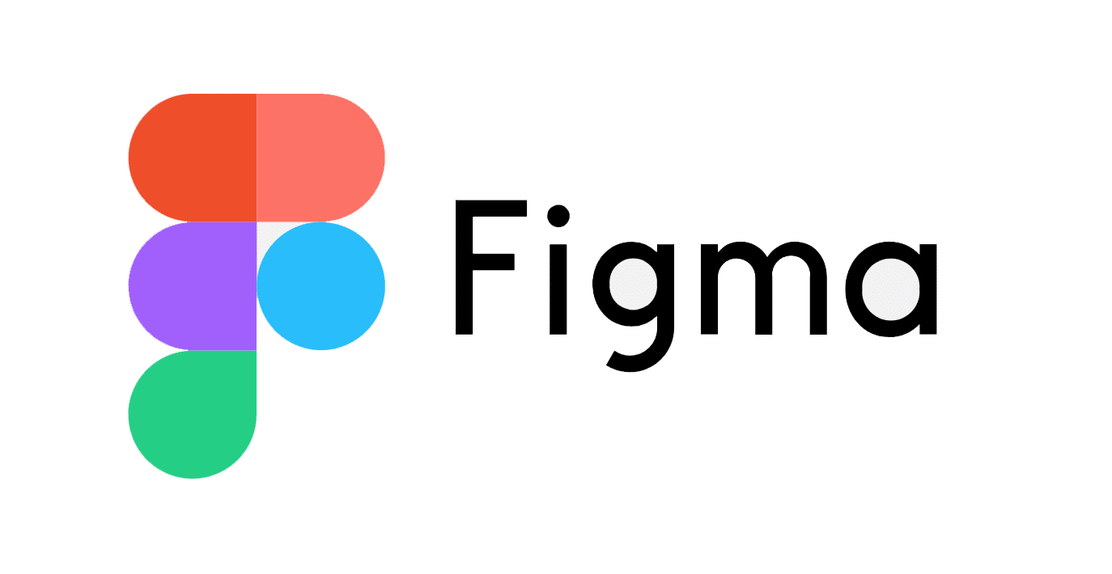

Our first task was to create a layout using Figma. We made a layout and with the help of the layout it was possible to visually understand the structure of the site.

*And this is my first job - creating a website layout:*

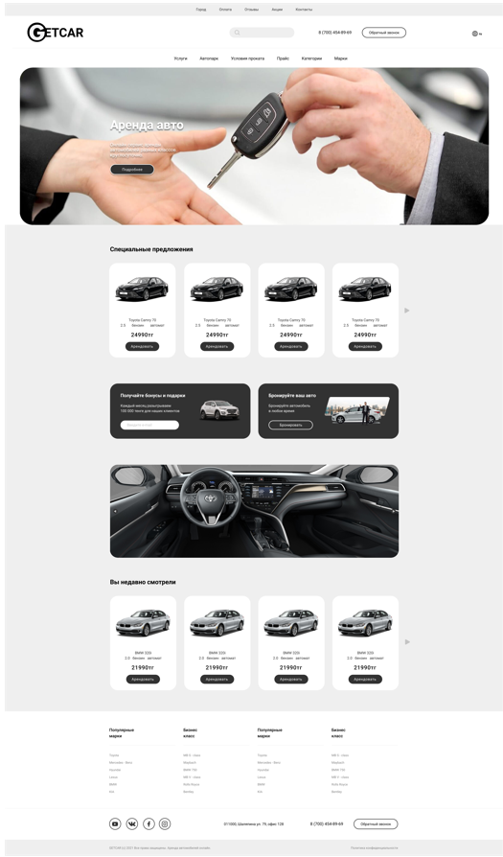

The layout was also uploaded on GitHub

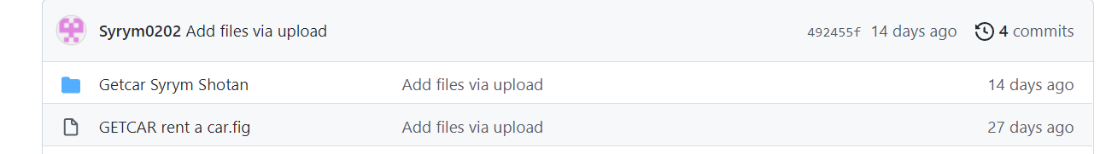

*Implementation (creation of website):*

*Home page:*

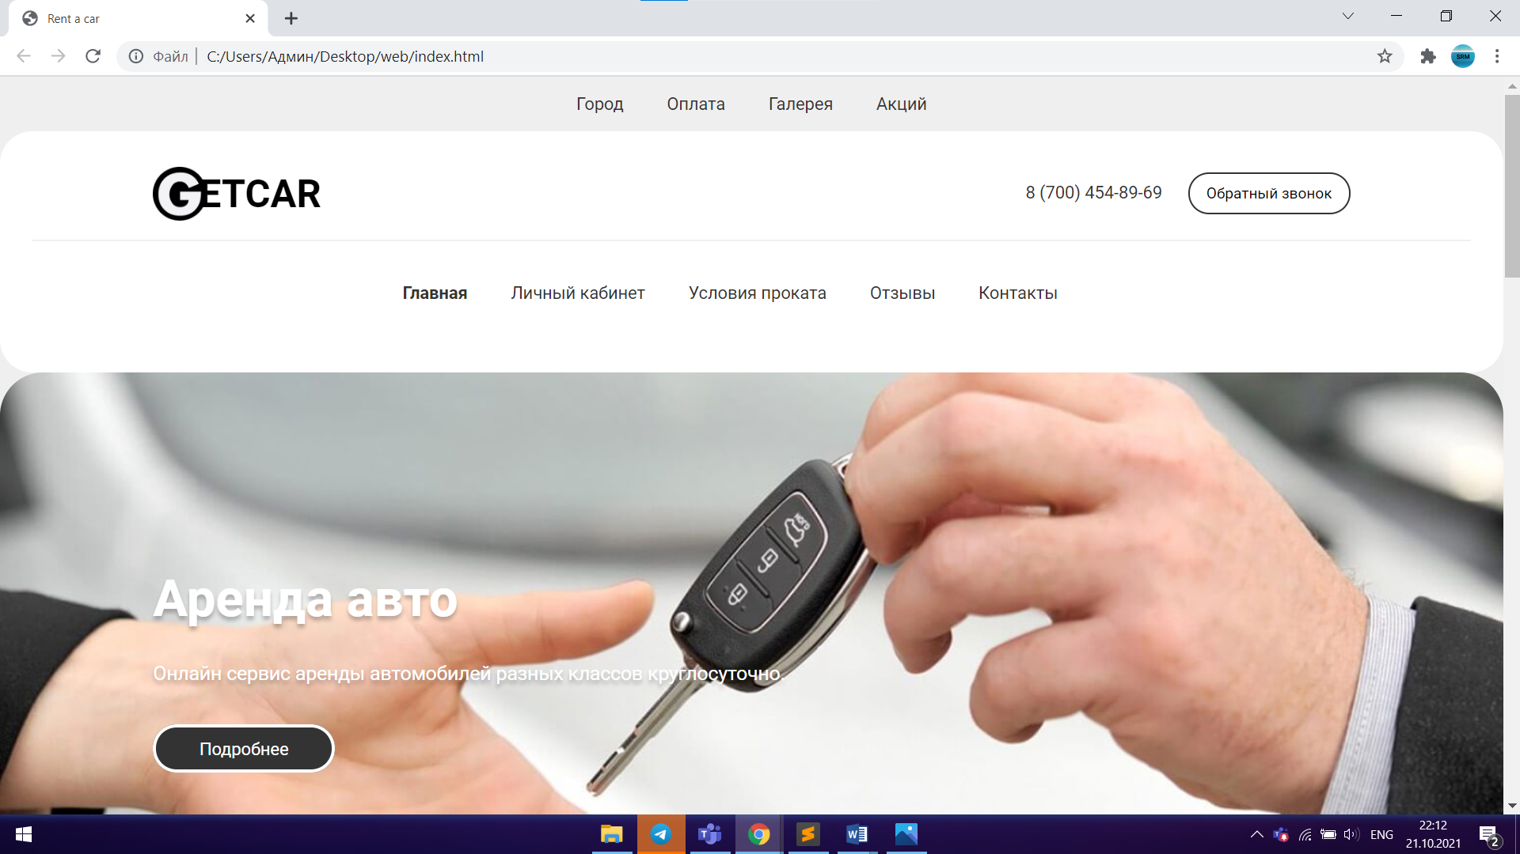

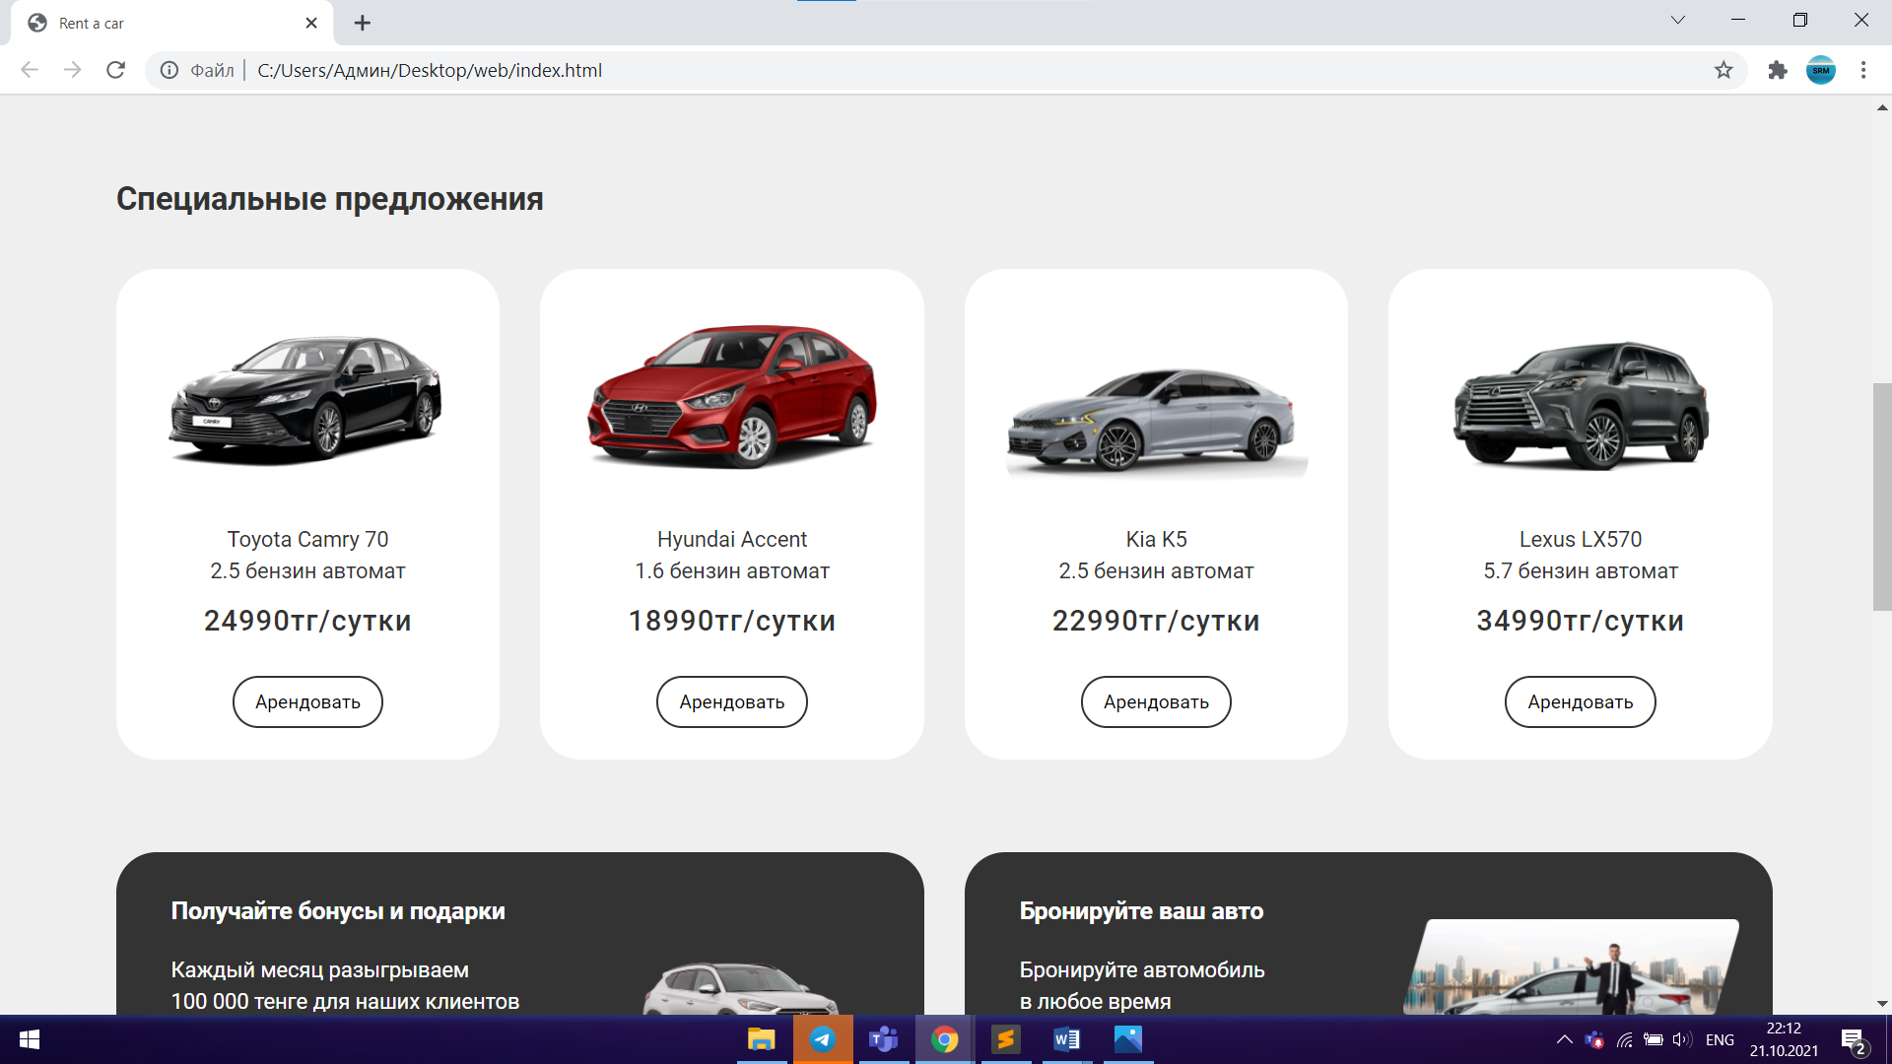

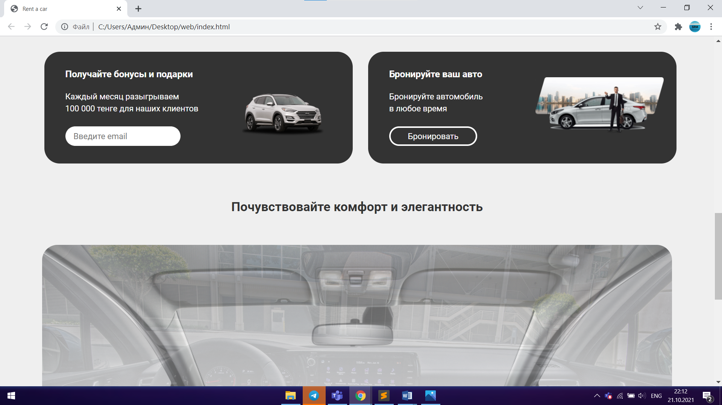

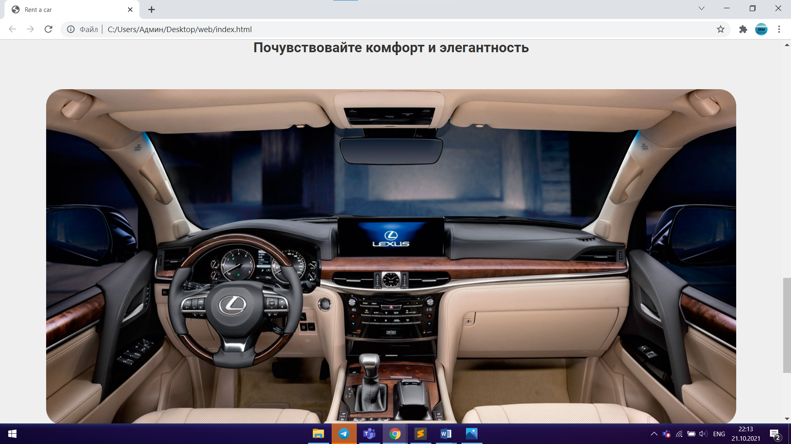

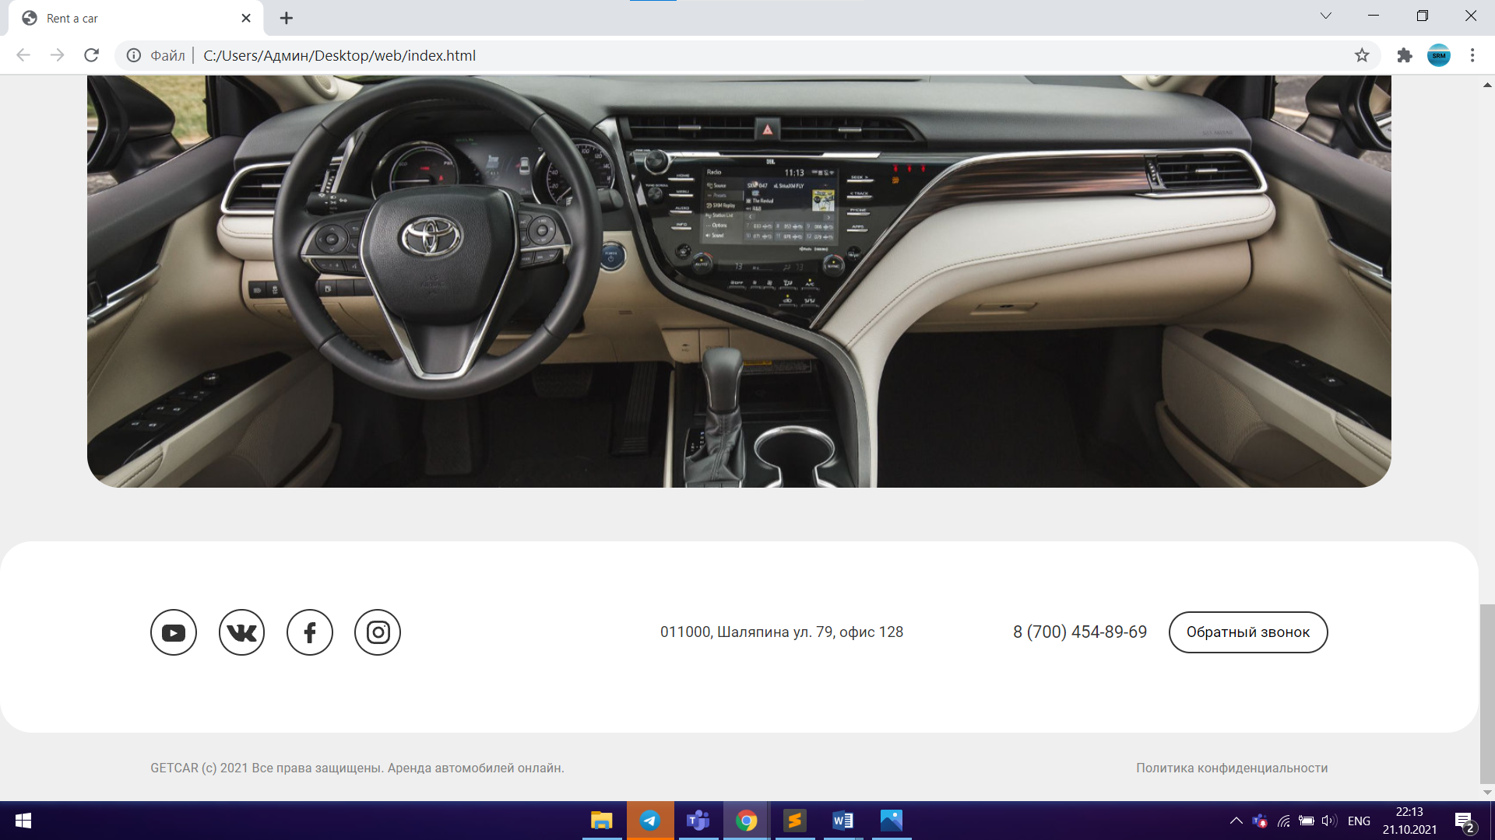

*registration page (registered):*

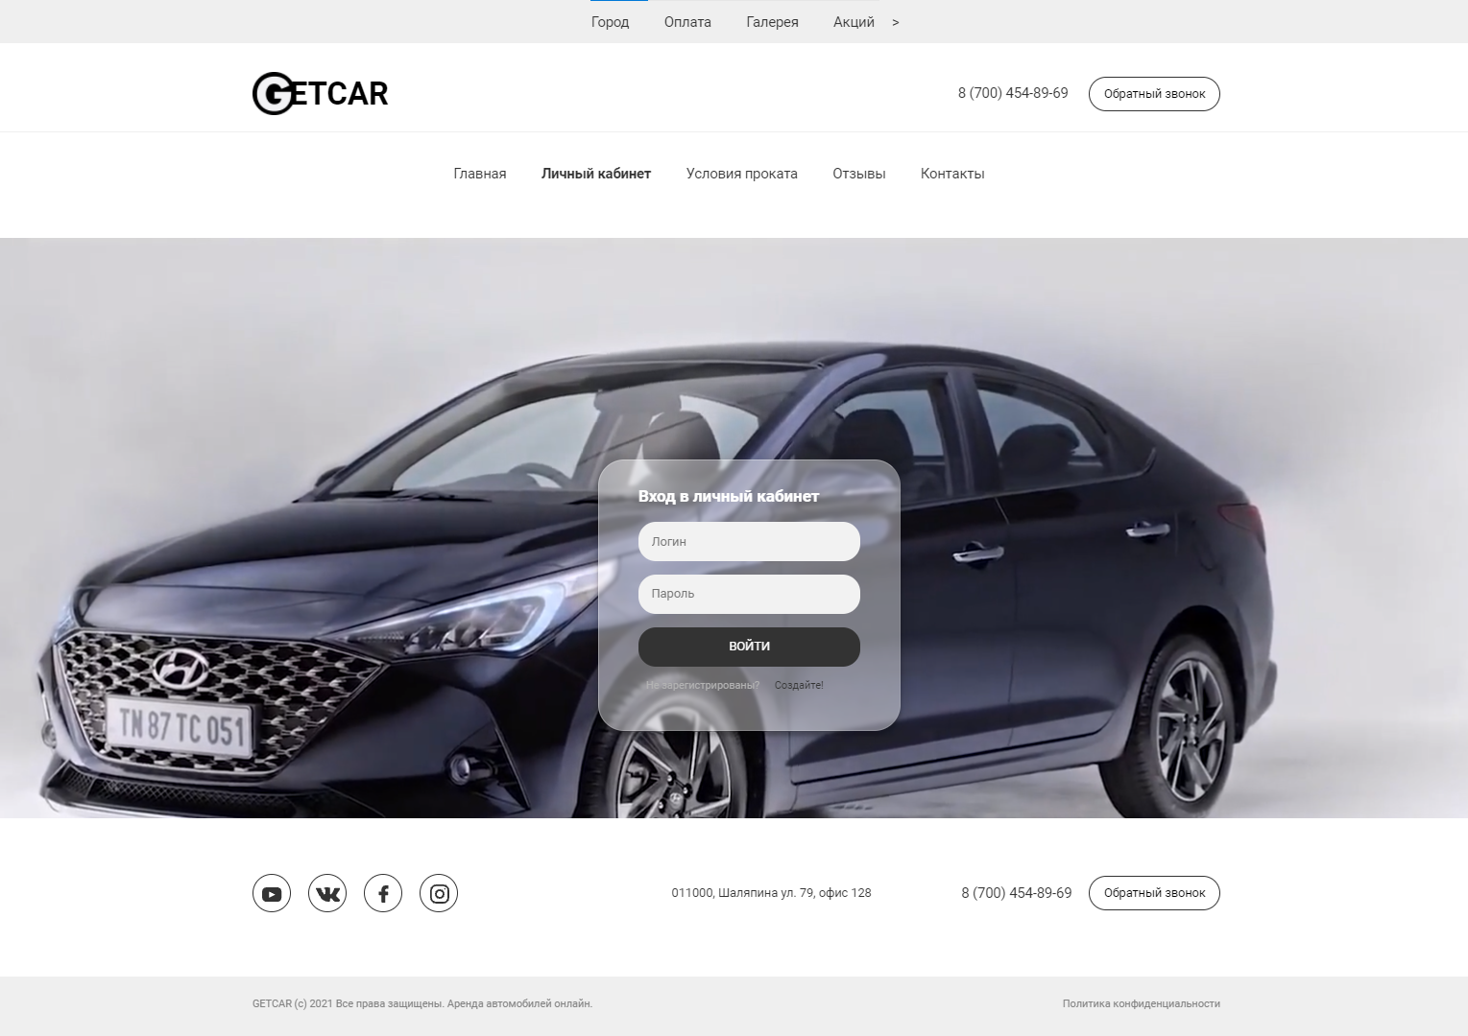

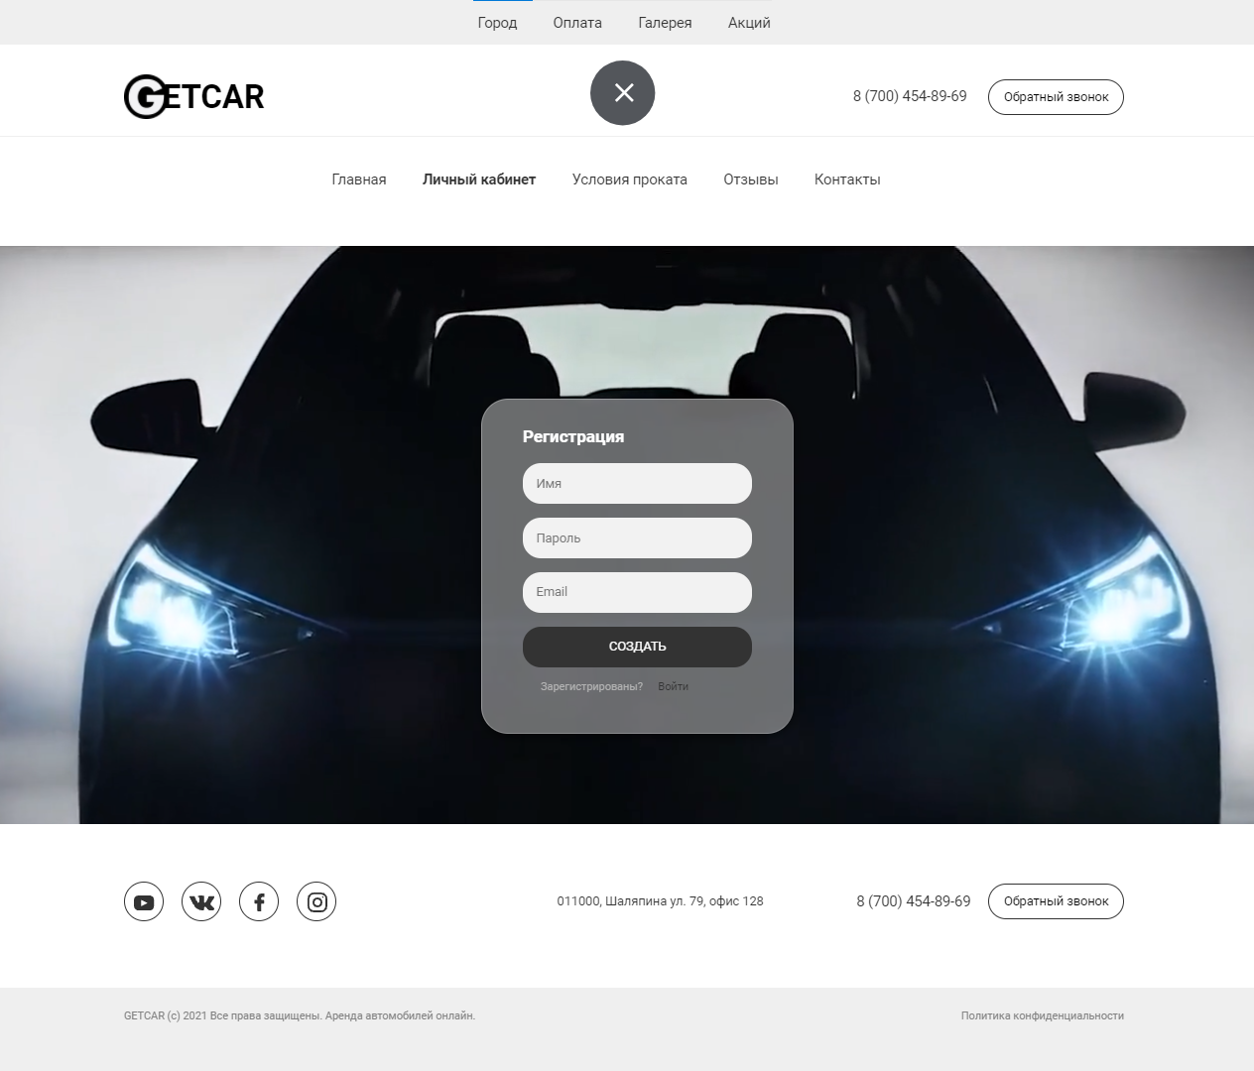

*rental conditions page:*

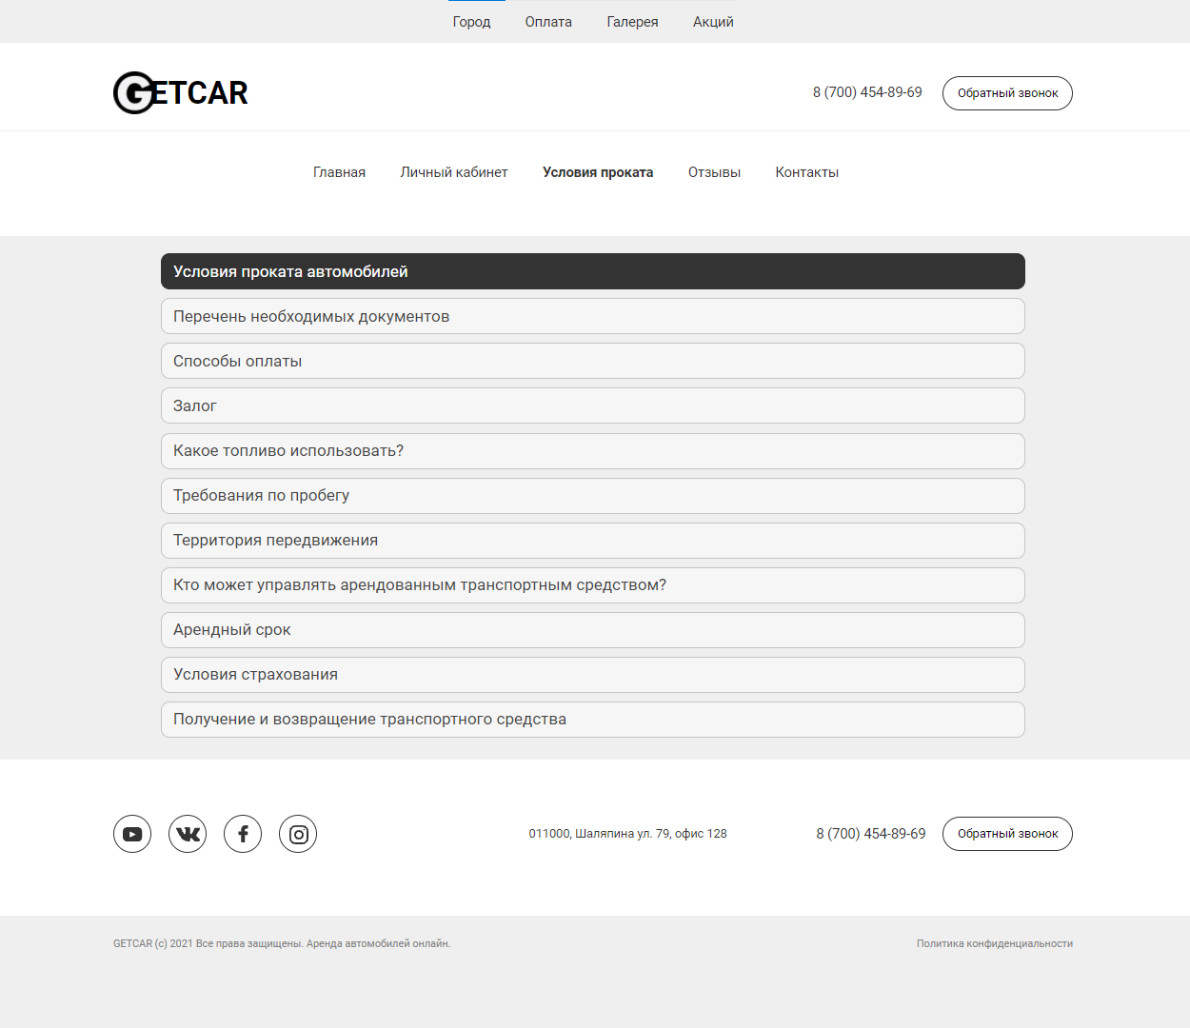

*reviews and galleries page:*

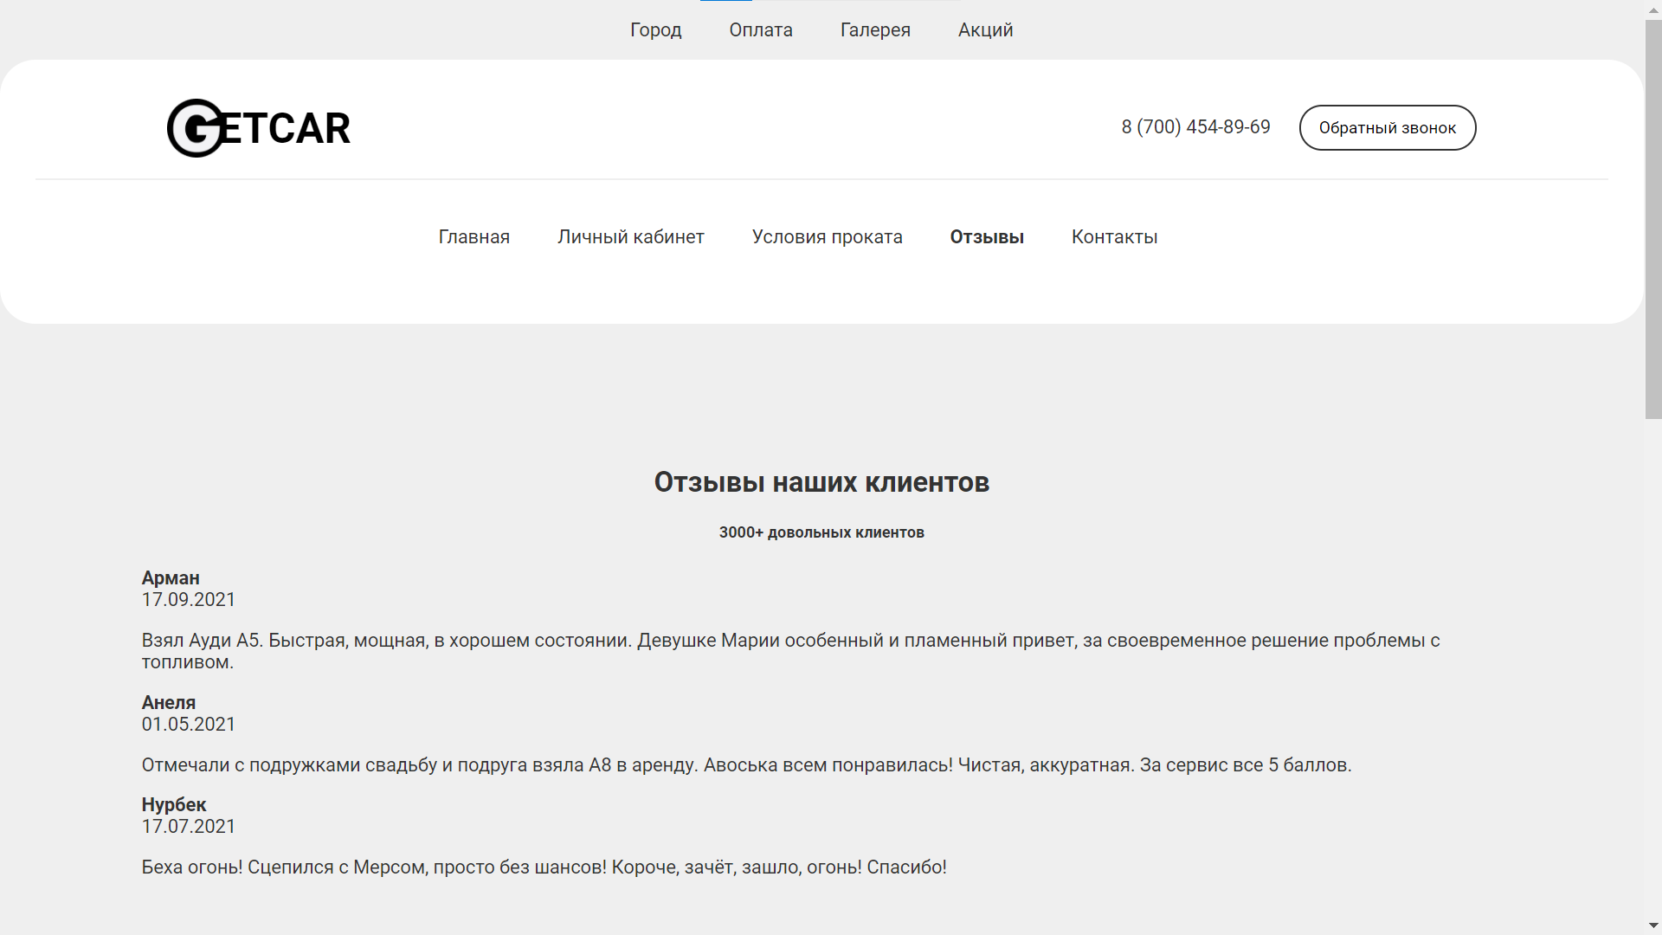

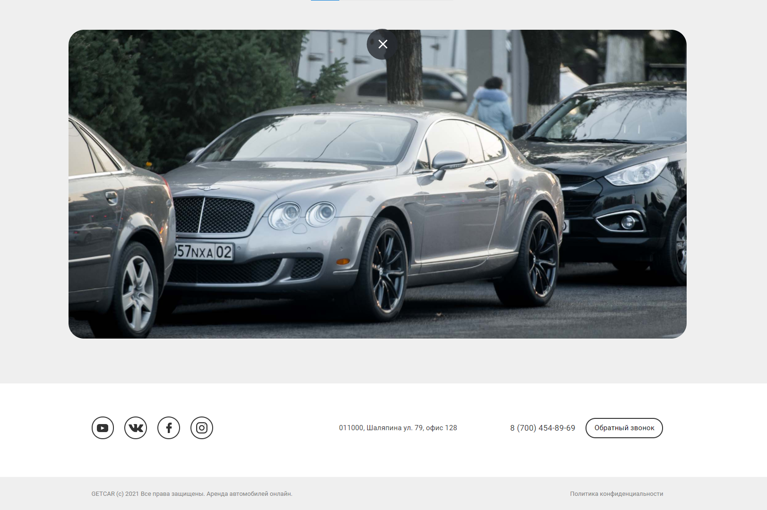

*contact page:*

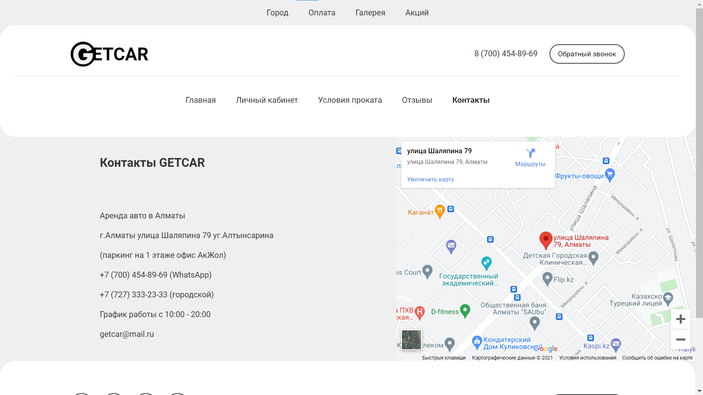

*We also had to make an admin panel:*

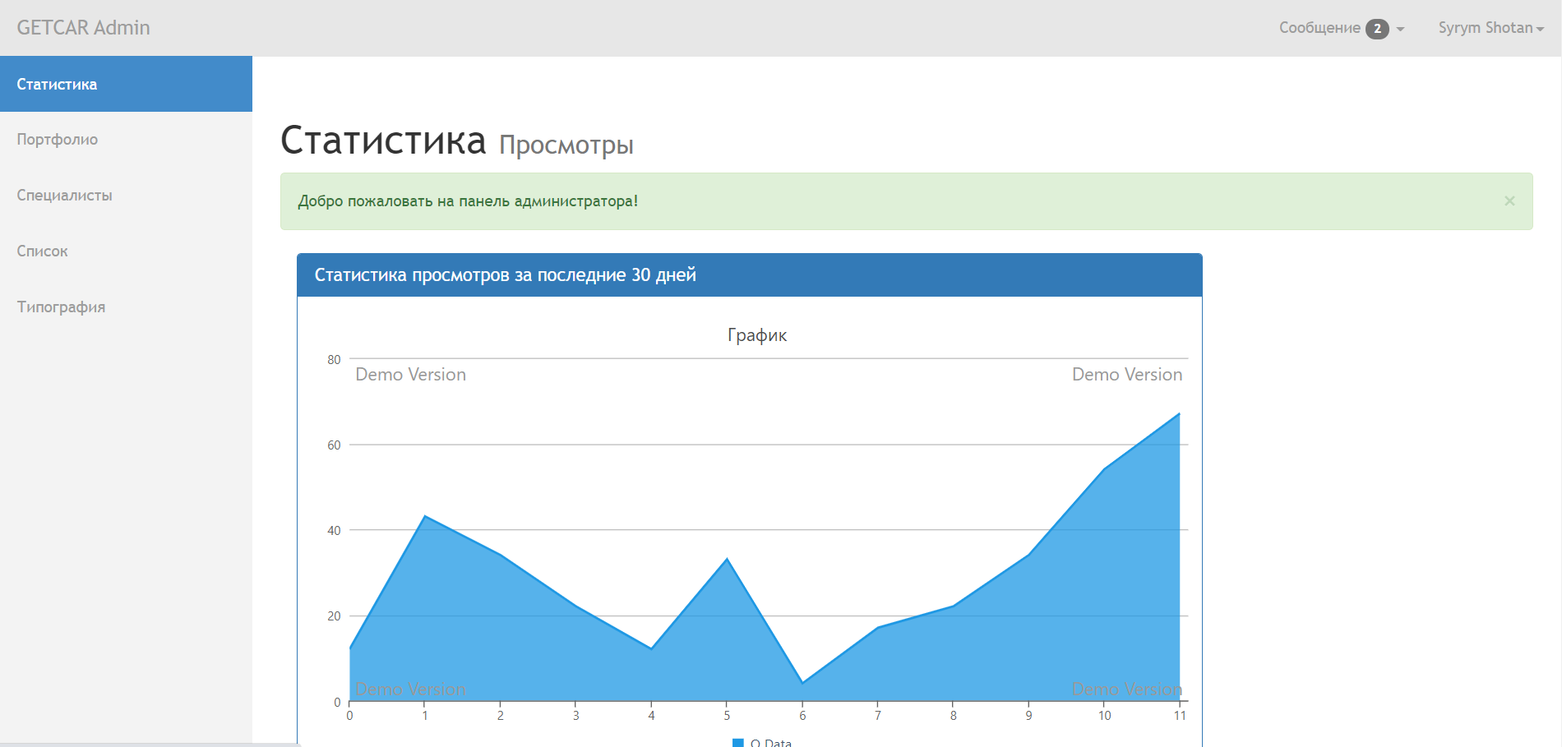

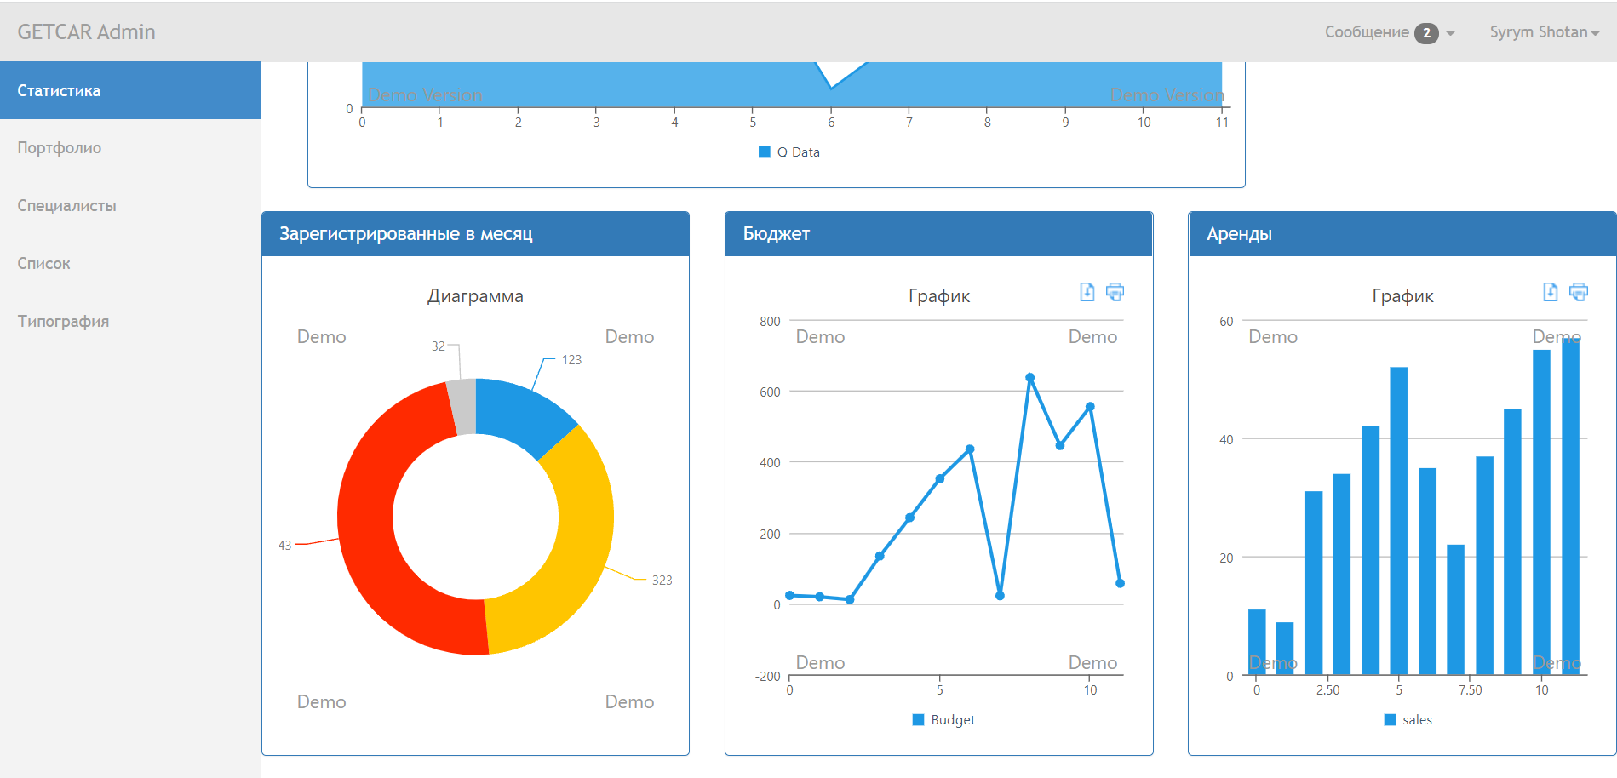

*Conclusion:*

In conclusion, I want to say that with the help of HTML CSS JS and Bootstrap, we learned how to make a full-fledged website (Front-end). In the future, this will be 100% useful to us.

The result of my site is filled in github.